Setting NGINX

NGINX is a popular lightweight web application that is used for developing server-side applications. It is an open-source web server that is developed to run on a variety of operating systems. Since **nginx** is a popular web server for development, Docker has ensured that it has support for **nginx**.

We will now see the various steps for getting the Docker container for **nginx**up and running.

**Step 1** − The first step is to pull the image from Docker Hub. When you log into Docker Hub, you will be able to search and see the image for **nginx** as shown below. Just type in nginx in the search box and click on the **nginx**(official) link which comes up in the search results.

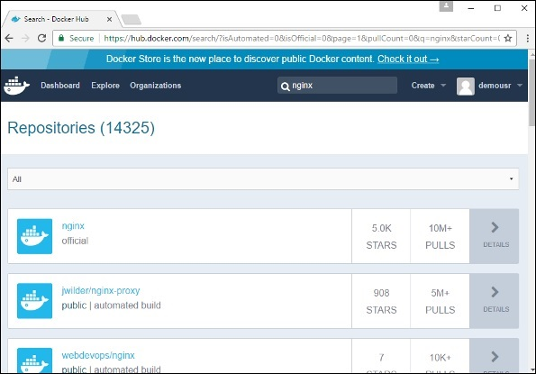

**Step 2** − You will see that the Docker **pull** command for **nginx** in the details of the repository in Docker Hub.

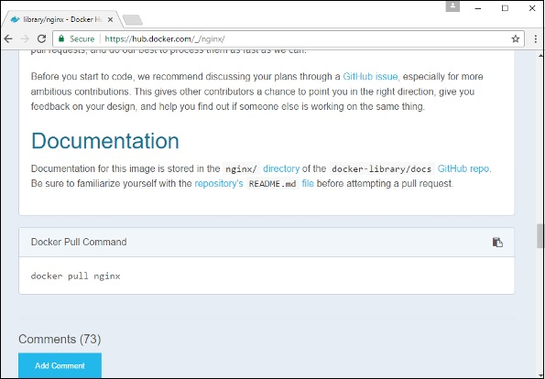

**Step 3** − On the Docker Host, use the Docker **pull** command as shown above to download the latest nginx image from Docker Hub.

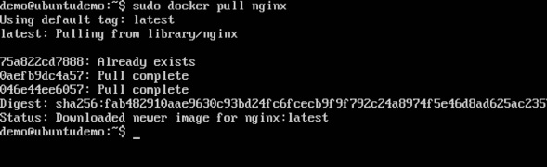

**Step 4** − Now let’s run the **nginx** container via the following command.

sudo docker run –p 8080:80 –d nginx

We are exposing the port on the **nginx** server which is port 80 to the port 8080 on the Docker Host.

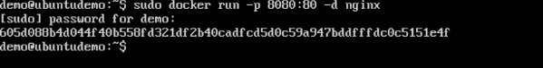

Once you run the command, you will get the following output if you browse to the URL **http://dockerhost:8080**. This shows that the **nginx** container is up and running.

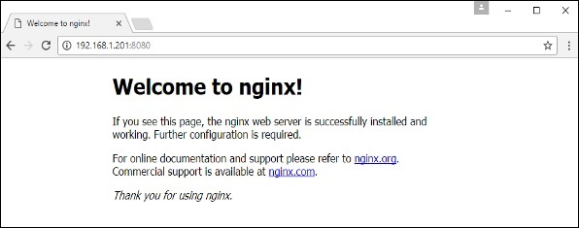

**Step 5** − Let’s look at another example where we can host a simple web page in our **ngnix** container. In our example, we will create a simple **HelloWorld.html** file and host it in our **nginx** container.

Let’s first create an HTML file called **HelloWorld.html**

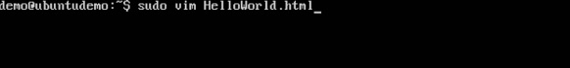

Let’s add a simple line of Hello World in the HTML file.

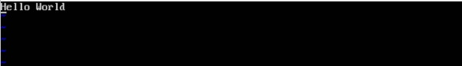

Let’s then run the following Docker command.

sudo docker run –p 8080:80 –v

“$PWD”:/usr/share/nginx/html:ro –d nginx

The following points need to be noted about the above command −

* We are exposing the port on the **nginx** server which is port 80 to the port 8080 on the Docker Host.
* Next, we are attaching the volume on the container which is **/usr/share/nginx/html** to our present working directory. This is where our HelloWorld.html file is stored.

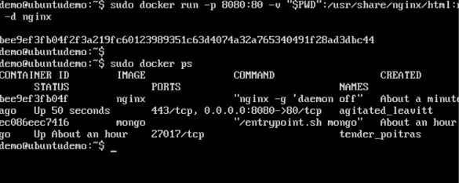

Now if we browse to the URL **http://dockerhost:8080/HelloWorld.html**we will get the following output as expected −

